**Predictive Modeling for Property Prices in Boston**

Prepared by Jacopo Belardo  
For JB Real Estate Agency   
October 18, 2024

**Introduction**

As a real estate agency, predicting property prices is crucial for staying competitive in the market. Understanding how various factors influence housing prices can help your agency refine pricing strategies and offer clients more accurate property valuations. In this analysis, I used data from Boston’s housing market to build predictive models that forecast housing prices based on various features such as crime rate, property tax rates, and proximity to important roads. The purpose of this analysis is to give your agency a tool that helps track market trends and make well-informed pricing decisions across different neighborhoods.

**Problem**

The main objective of this analysis was to determine the key factors influencing property prices in Boston and assess how accurately we could predict these prices using a statistical model. With access to detailed data on Boston properties, I focused on building a predictive model that accurately forecasts housing prices. This is particularly relevant for your agency, as better price predictions can lead to more strategic pricing decisions, optimized listings, and improved client satisfaction.

**Analysis**

To achieve this goal, I used a method known as stepwise regression, which identifies the most important factors from the available data by adding or removing variables step-by-step. I developed three versions of the model (forward selection, backward elimination, and both direction) to ensure we found the best combination of factors that affect housing prices.

Instead of focusing on technical details, I want to provide you with a simplified version of how the model works: the algorithm starts with all (or no) variables and evaluates their importance one by one, adding or removing variables to create the best possible combination for price prediction. The three models I developed were nearly identical, suggesting that the key variables affecting property prices are consistent.

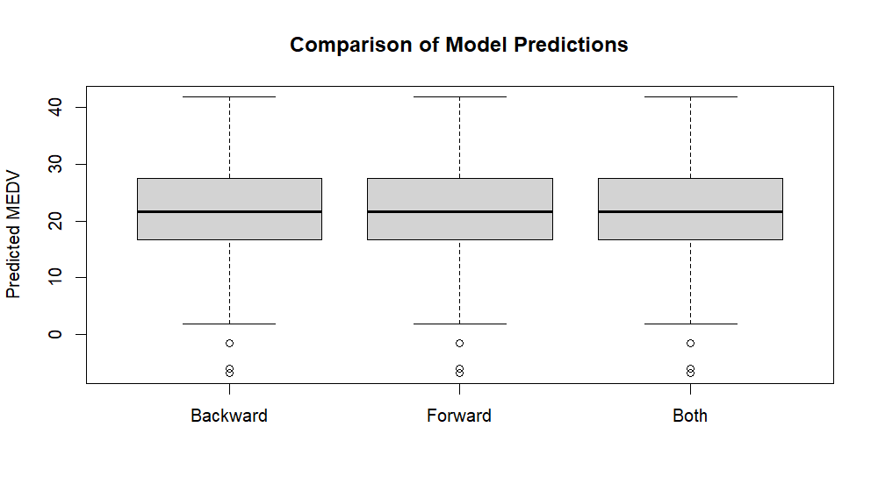

This graph shows that the models have the same exact predictive power and produce identical results when they are asked to predict the median price of houses in the Boston area.

**Key Factors**

* **Crime Rate**: Higher crime rates tend to lower property values.
* **Proximity to the Charles River**: Properties near the Charles River are valued higher.
* **Number of Rooms**: Homes with more rooms tend to have higher prices.
* **Accessibility to Main Roads**: Properties closer to main roads are more expensive due to better connectivity.
* **Student-Teacher Ratios**: Lower student-teacher ratios correlate with higher property values, reflecting demand for better education quality.

**Results**

Using the stepwise models, I generated several key performance metrics, including Root Mean Squared Error (RMSE) and Mean Absolute Error (MAE), which measure the accuracy of price predictions. All three models produced nearly identical results, with RMSE values around 5.33, meaning the average error between predicted and actual prices is approximately $5,330. The Mean Absolute Error (MAE) was also similar, highlighting that the predictions are quite reliable across different models.

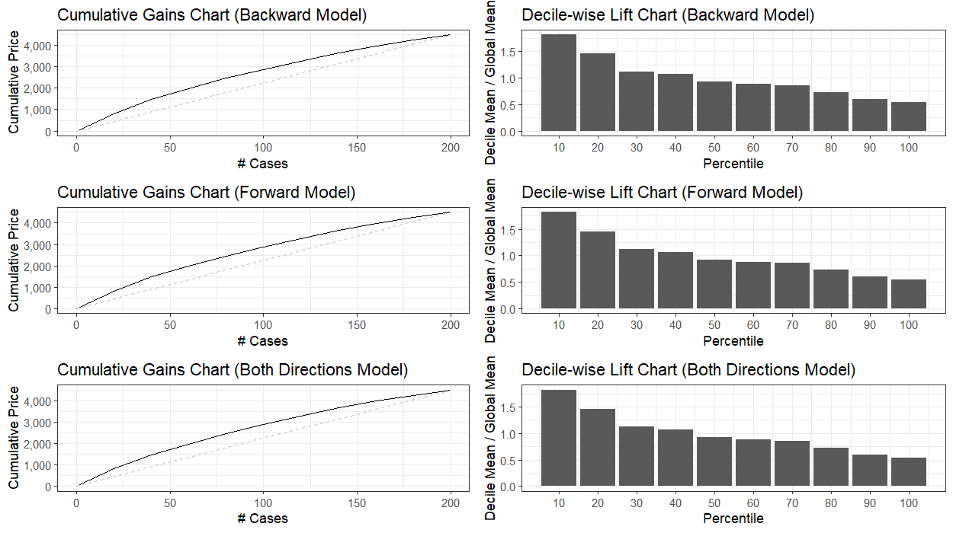

In addition, I used Lift Charts to visualize how well the models perform at predicting higher-priced properties compared to the average. The cumulative gains charts show how well the model identifies high-value properties. A steep curve means that the model is accurate. The decile-wise lift charts illustrate how well the model performs across different percentiles of properties. A high lift corresponds to a better prediction compared to random chance and the model is good at identifying high-value properties.

**Interpretation and Recommendations**

The models highlighted several critical variables that affect property pricing in Boston, and the analysis suggests that these variables can be effectively used to forecast future property prices. For your real estate agency, I recommend integrating a pricing model based on these findings into your property evaluation process that can offer:

* **Better Pricing Strategies**: By understanding which factors drive property prices, you can set more competitive and realistic prices for your listings.
* **Improved Client Satisfaction**: Accurate price predictions allow you to better advise clients on their property's value and the best time to buy or sell.
* **Valuable Market Insights**: These models can help you spot undervalued properties, making it easier to identify investment opportunities.

By using this predictive model, your agency can enhance its pricing strategies and offer clients more data-driven insights, ultimately improving client satisfaction and business performance.

**Next Steps**

* Integrate the model into your property evaluation process.
* Use the insights to adjust pricing strategies for current and future listings.
* Continue monitoring the model's performance to ensure it remains effective in changing market conditions.